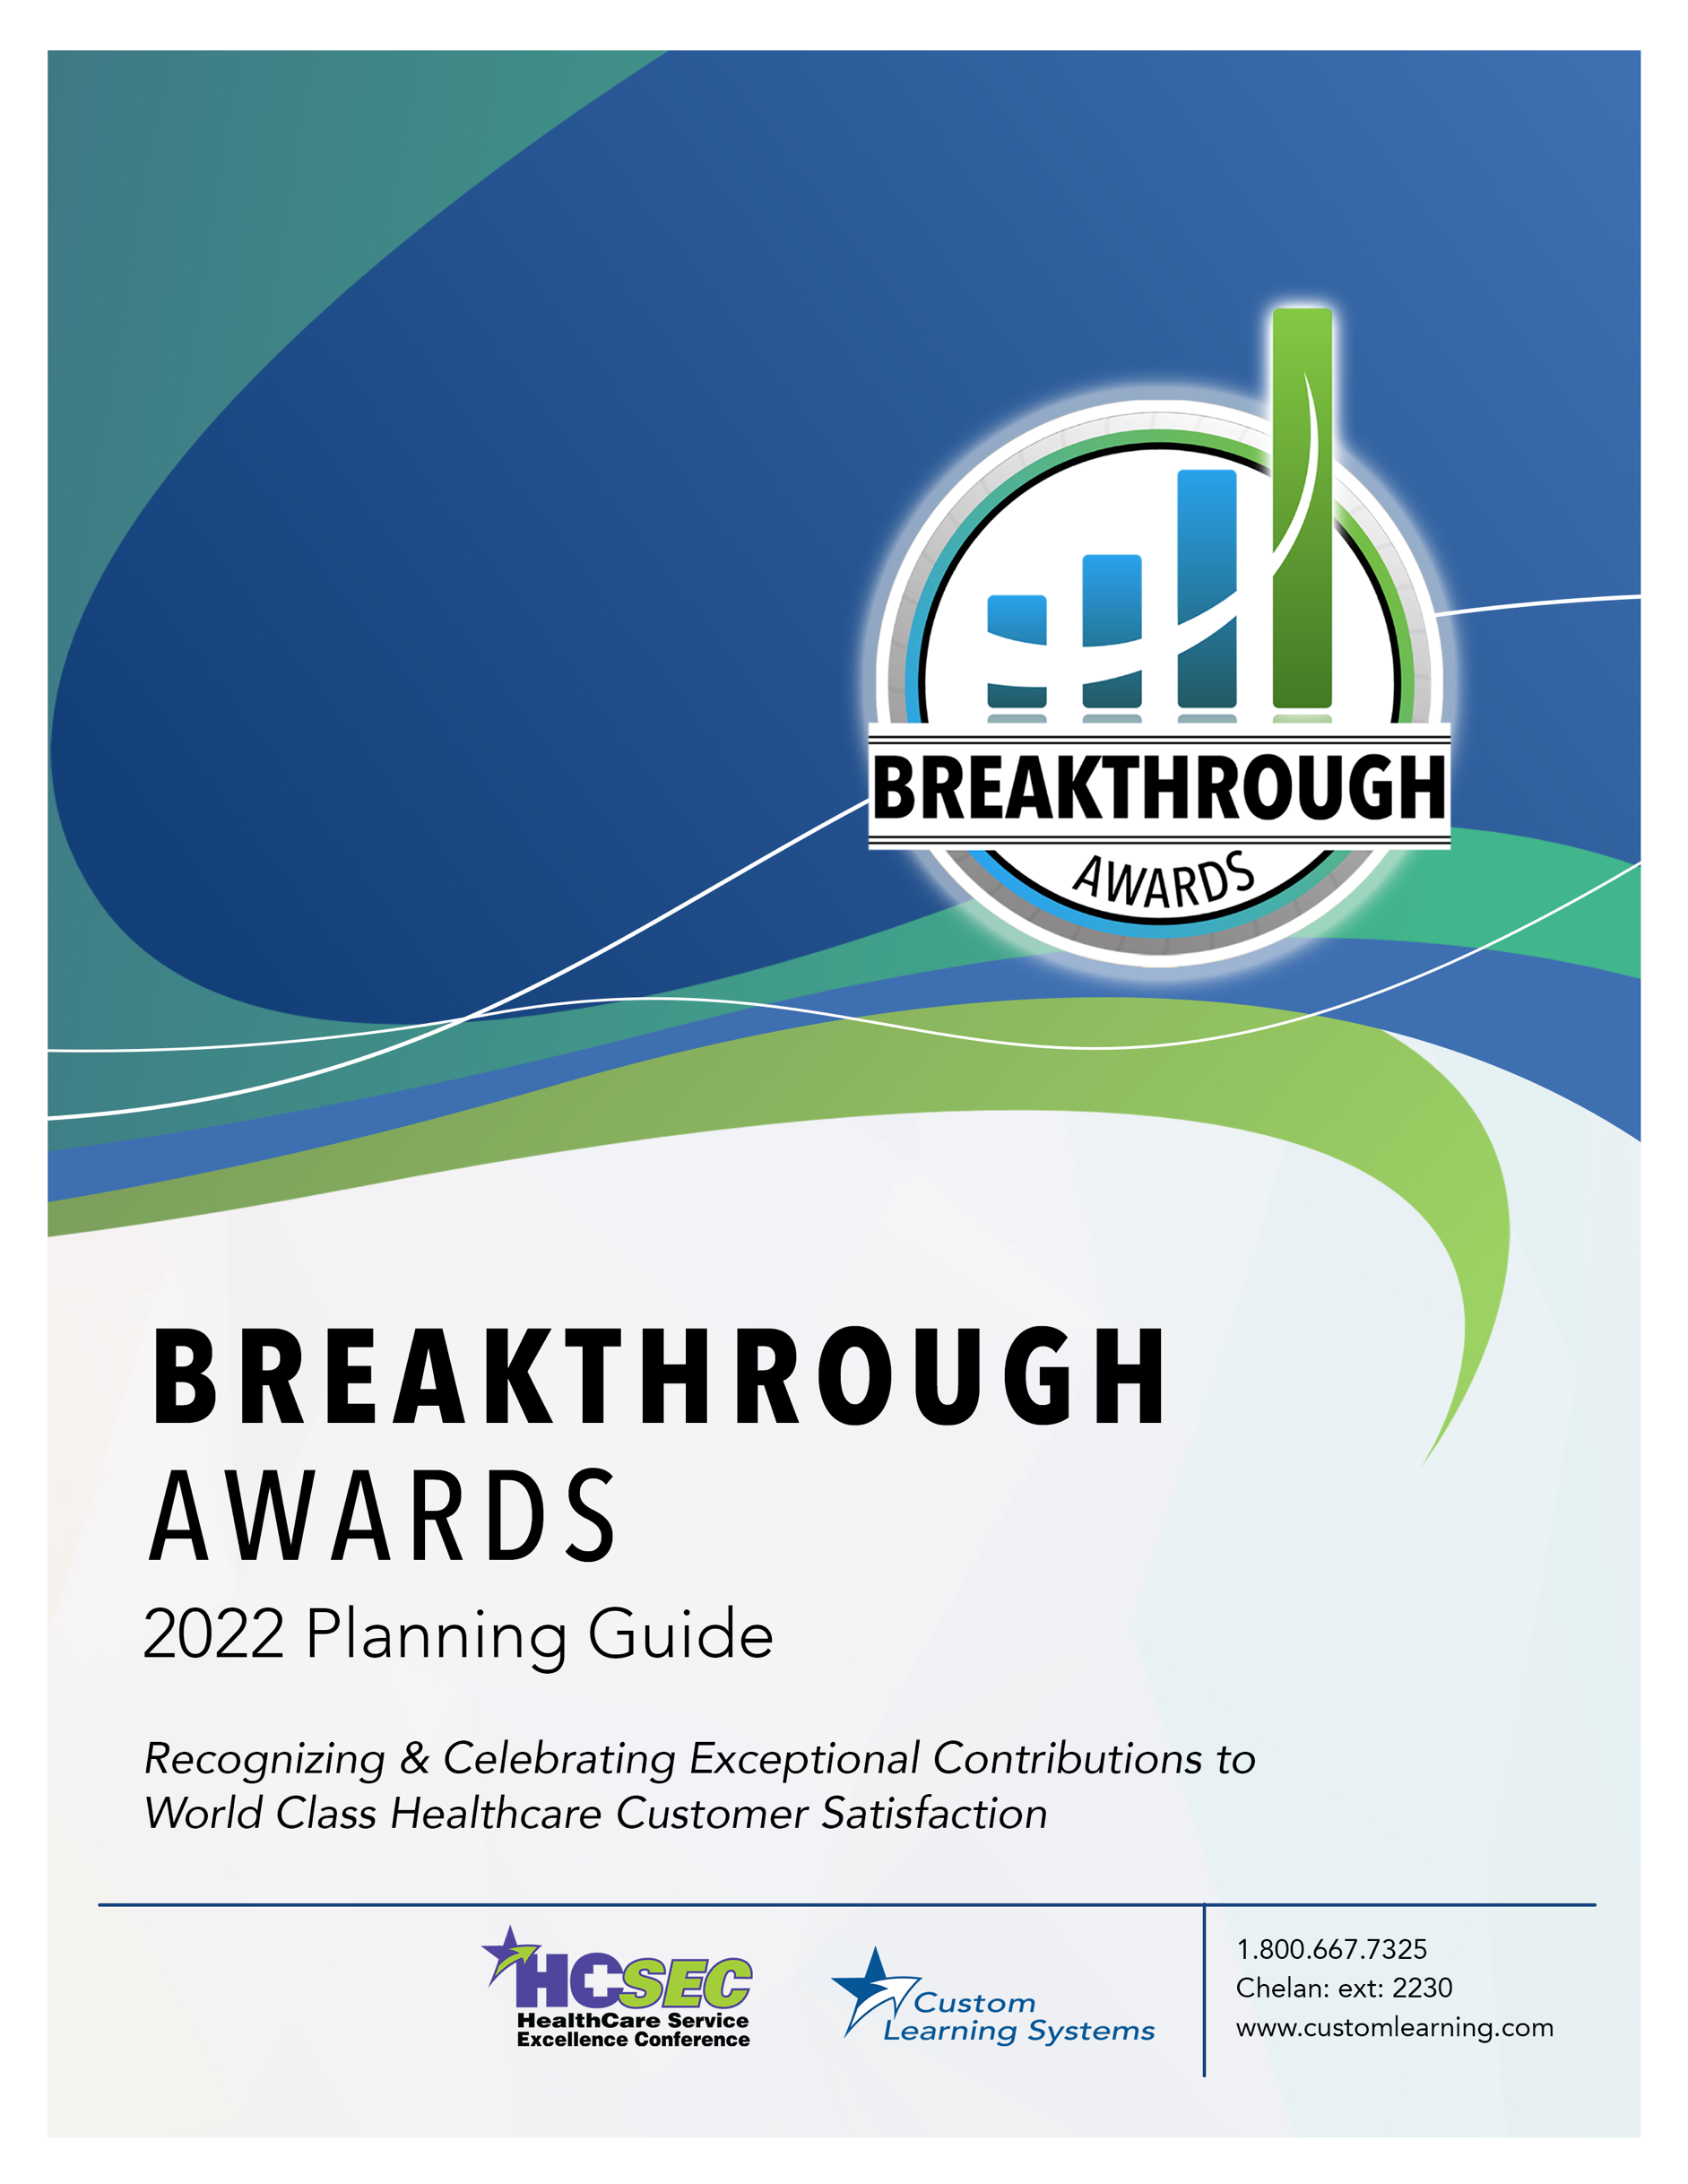

Table of Contents

Introduction 2
Rules and Regulations 2
Breakthrough Award Summary 3
Submission Form Patient Experience [HCAHPS] 4
Submission Form Patient Experience 5
[ED CAHPS, CG-CAHPS, OAS CAHPS, HH CAHPS]
Submission Form Patient Satisfaction 6

1

Breakthrough Awards 2022

Greetings!
This Breakthrough Awards Planning Guide will give you all the information you need to participate in the Breakthrough Awards process. Please to be sure to read through this document in its entirety as new awards have been added and criteria has changed from previous years.

Guidance, Rules & Regulations, and Form Completion
(Guidance is provided for anything of concern – not limited to just rules and regulations)

Martha Jasinski
HCSEC Awards Vice-Chair
info@hcsecawards.com
Phone: 1-800-667-7325 ext. 2203
Chelan MacMillan
HCSEC Awards Chair
info@hcsecawards.com
Phone: 1-800-667-7325 ext. 2230

Rules and Regulations
- The HCSEC Breakthrough Awards are available only to organizations participating in the Service Excellence Initiative™.
- Only surveys with at least 8 responses will be accepted to ensure a reasonable assessment.
- Survey vendor reports must accompany each submission.
Vendor reports must have the scores either highlighted or circled when submitted.
- All comparative scores must be from your survey vendor database.
- The individual nomination forms are available to download at www.hcsecawards.com.
- Nomination forms must be completed electronically. All submissions and documentation are to be submitted online at www.hcsecawards.com. (Please no handwritten or PDF nomination forms.)
- All eligible submissions will be acknowledged during the HealthCare Service Excellence Conference in Orlando, FL, November 14-16, 2022.
- The deadline for nominations to be received by the judges is Friday, October 7, 2022.
- You will receive a summary of the awards you have qualified for prior to the Conference. This will give you a chance to review and correct any discrepancies.
These awards are administered by the HealthCare Service Excellence Conference and all qualified submissions will be recognized and receive a certificate of achievement presented at the 22nd Annual HealthCare Service Excellence Conference at the Breakthrough Awards Luncheon, in Orlando, FL on Wednesday, November 16, 2022. Please join us there.
Your participation is invited. Your organization’s recognition awaits your submissions.

Breakthrough Award Summary

The Breakthrough Awards are open to all Service Excellence Initiative™ participants and alumni. The awards serve to draw attention to and reward excellence in Patient Satisfaction and Patient Experience. The deadline for submissions is Friday, October 7, 2022.

Here is a summary of all the awards available (Forms on following pages):

- Patient Experience [HCAHPS] Form on Page 4
Improvement
Bronze: At least 5 percentage points based on Top Box Score
Silver: At least 10 percentage points based on Top Box Score
Gold: At least 15 percentage points based on Top Box Score
Achievement
Emerald: Greater than the comparative database average
Ruby: At least 5 percentage points higher than the comparative Top Box Score
Diamond: At least 10 percentage points higher than the comparative Top Box Score

- Patient Experience [ED CAHPS, CG-CAHPS, OAS CAHPS, HH CAHPS] Form on Page 5
Improvement
Bronze: At least 5 percentage points based on Top Box Score
Silver: At least 10 percentage points based on Top Box Score
Gold: At least 15 percentage points based on Top Box Score
Achievement
Emerald: Greater than the comparative database average
Ruby: At least 5 percentage points higher than the comparative Top Box Score
Diamond: At least 10 percentage points higher than the comparative Top Box Score

- Patient Satisfaction Form on Page 6
Improvement
Bronze: At least 2 mean score improvement points
Silver: At least 3 mean score improvement points
Gold: At least 4 mean score improvement points
Achievement
Emerald: At least 75th Percentile (Based on Vendor Database)
Ruby: At least 90th Percentile (Based on Vendor Database)
Diamond: At least 95th Percentile (Based on Vendor Database)

Breakthrough Award Submission Form
Patient Experience [ HCAHPS ]

- Please enter your Top Box Percentages as outlined in the form below.
- Each score will need to be validated by your Survey Vendor Report.
- Vendor reports must have the scores either highlighted or circled when submitted.
HCAHPS  DOMAIN | Your Top Box Percentage  July 2020 – June 2021  (Rolling Year to Date/Average) | Your Top Box Percentage  July 2021 – June 2022  (Rolling Year to Date/Average) | Top Box Percentage  National Average  July 2021 – June 2022
Communication with Nurses
Communication with Doctors
Response of Hospital Staff
Communication about Medicines
Hospital Environment - Clean
Hospital Environment - Quiet
Discharge Information
Transition of Care
Rate Hospital (9-10)
Recommend the Hospital

Submitted by:

Organization:

Contact Person: Title:

Phone:

Email:

Validated by: (Attach a copy of your survey vendor’s report for each submission)

Survey Vendor:

Contact Person: Title:

Phone:

Email:

Breakthrough Award Submission Form
Patient Experience [ ED CAHPS, CG-CAHPS, OAS, & HH CAHPS ]
- Please enter your Top Box Percentages as outlined in the form below.
- Each score will need to be validated by your Survey Vendor Report.
- Vendor reports must have the scores either highlighted or circled when submitted.
DOMAIN | Your Top Box Percentage  July 2020 – June 2021  (Rolling Year to Date/Average) | Your Top Box Percentage  July 2021 – June 2022  (Rolling Year to Date/Average) | Top Box Percentage  National Average  July 2021 – June 2022
ED CAHPS
CG-CAHPS
OAS CAHPS
HH CAHPS

Submitted by:
Organization:
Contact Person: Title:
Phone:
Email:
Validated by: (Attach a copy of your survey vendor’s report for each submission)
Survey Vendor:
Contact Person: Title:
Phone:
Email:
Breakthrough Award Submission Form
Patient Satisfaction

- Please enter your Mean Scores and/or Percentile as outlined in the form below.
- Each score will need to be validated by your Survey Vendor Report.
- Vendor reports must have the scores either highlighted or circled when submitted.
Service | Your Mean Score  July 2020 – June 2021  (Rolling Year to Date/Average) | Your Mean Score  July 2021 – June 2022  (Rolling Year to Date/Average) | Percentile  July 2021 – June 2022  (Rolling Year to Date/Average)
Inpatient
Outpatient
Emergency
Ambulatory
Physician Clinic
Home Care
Other
Other
Other
Other
Other

Submitted by:
Organization:
Contact Person: Title:
Phone:
Email:
Validated by: (Attach a copy of your survey vendor’s report for each submission)
Survey Vendor:
Contact Person: Title:
Phone:
Email:

